

User Manual
Performance Module
www.flowhcm.com



Contents
Performance Setup 3
Performance Information 4
Performance Option 5
Objective & KPI’s 8
Evaluation Guidelines 12
Performance Review 13
Performance Evaluation 15
Performance Approval 18
Performance Settings 19
Performance Template 20
KPI Library 21
Review Category 22
Matrix Box 23

Performance Setup

- Navigate to Others Tab and click performance
- To add performance setup, click on Add New Setup button

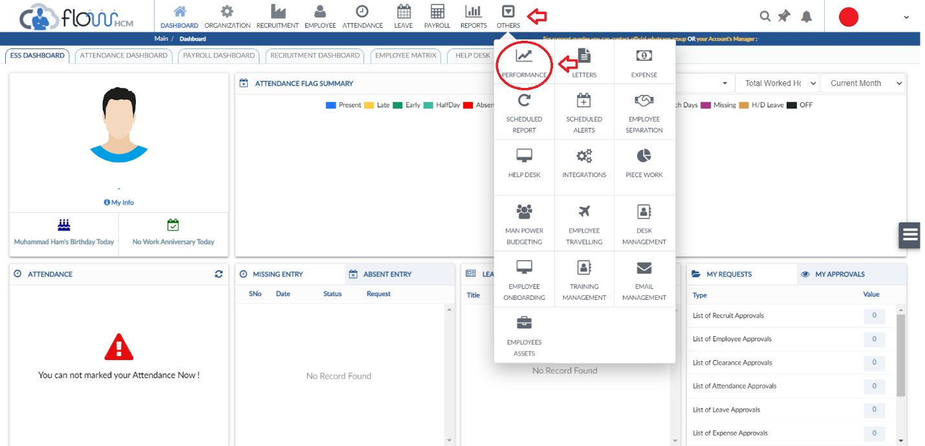
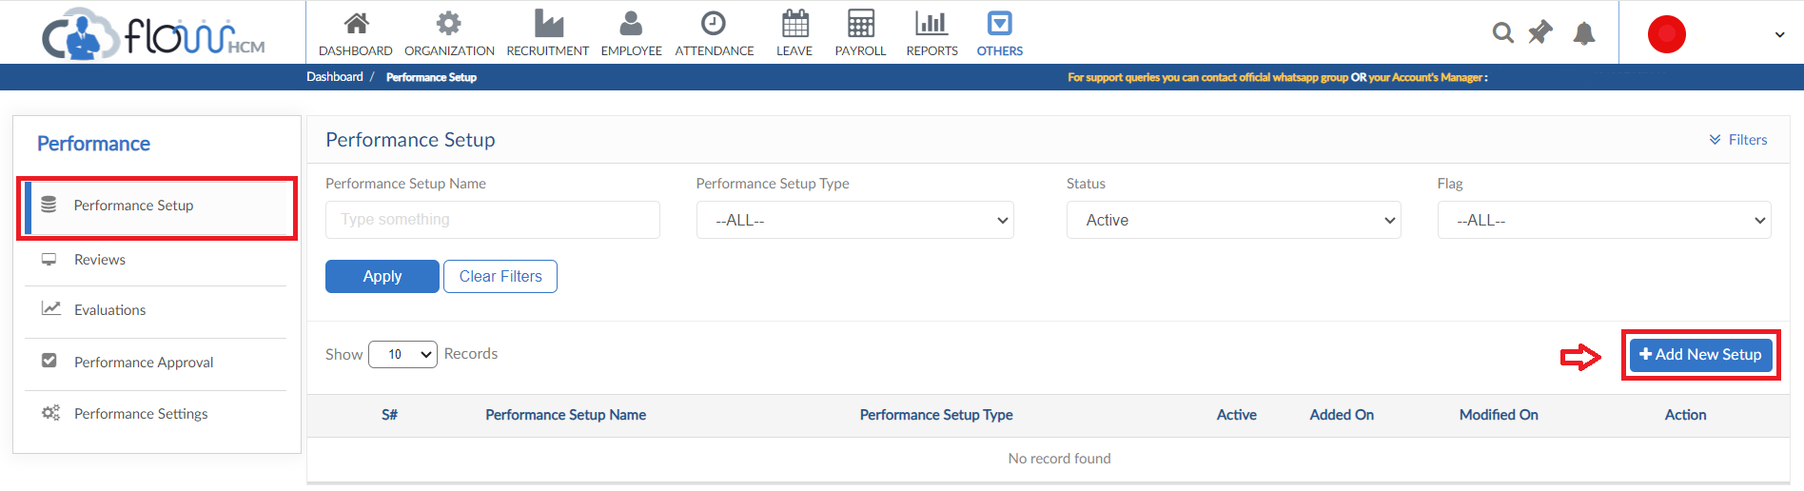

Performance Information
- Enter Performance Setup title and description
- Click save to proceed
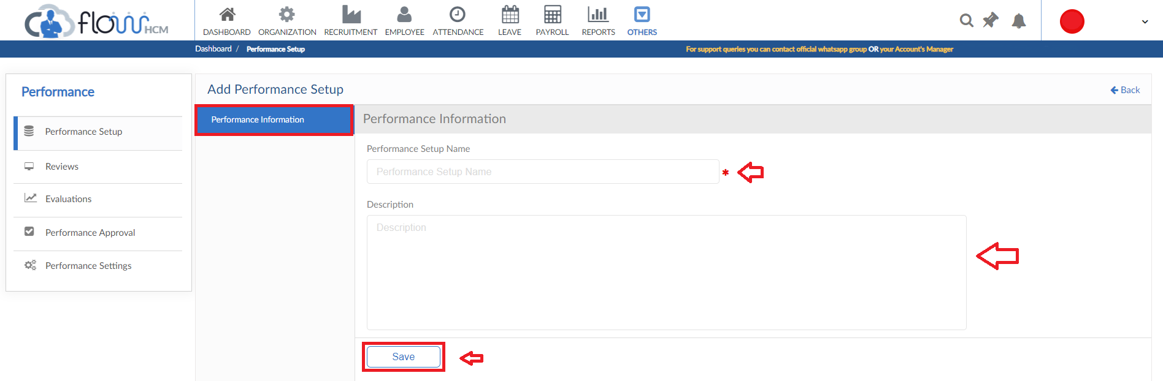

Performance Option
- After saving information select next tab of performance option in setup screen
- Set the parameters in performance option (Limits, weightage, restrictions etc.)
- Selection of KPI choices and scoring
- User Additional feedback tiles (Feedback to Manager, Strengths, Development Plan and Areas of Development)
- File attachment option enable/disable in Evaluation
- Raise Suggestion policy along with the title
- Final score can be set slab wise according to the percentages assigned for every review type
- Set request forwarding for Objective/KPI requests and click update to save
- After saving the settings, expected evaluation button generates a view of evaluation form in accordance to the parameters

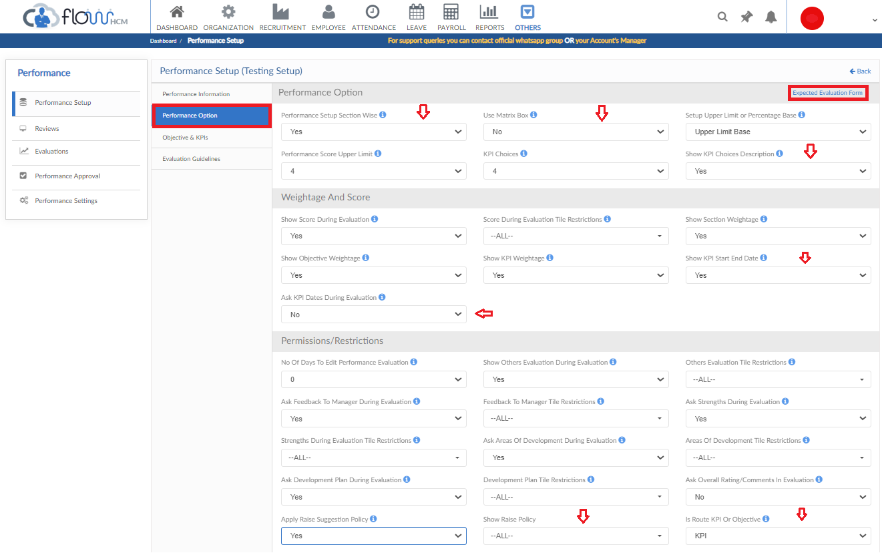
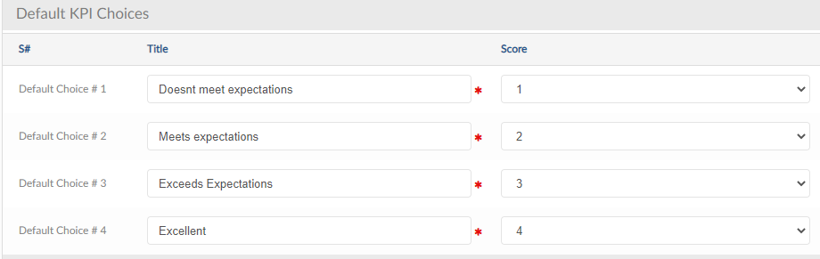

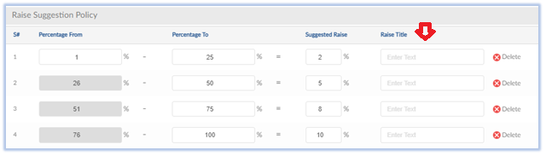
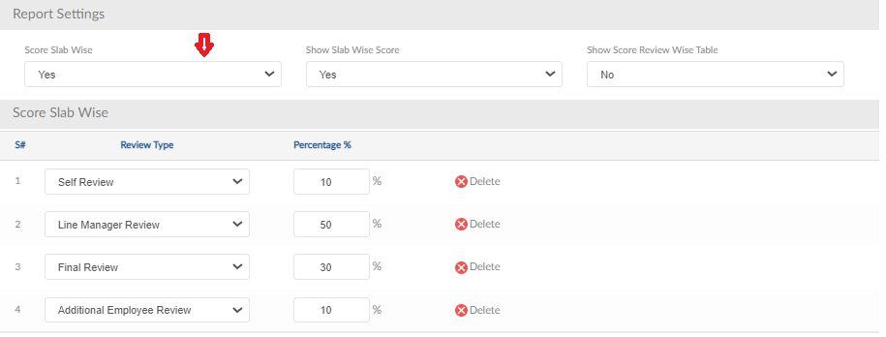
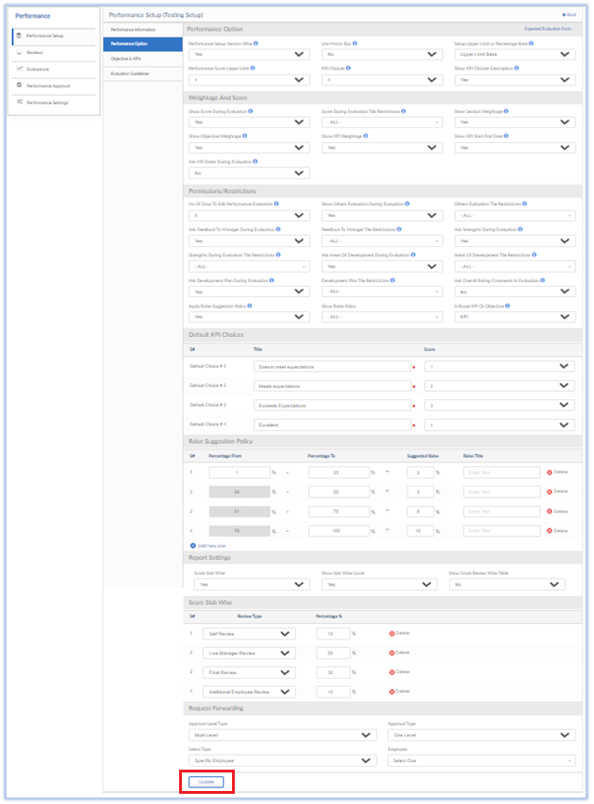

Objective & KPI’s
- Next step is to add Section, objectives and KPI’s, click on New Section button
- Add Section information and save
- Click on New Objective and enter objective information, if the KPI’s are to be created by the Employee/Line Manger select YES in Allow Manager to Write KPI and click save
- Add KPI details respectively
- KPI start end date can be added to show on evaluation form
- KPI choice description can be entered to explain the choice detail
- Click save

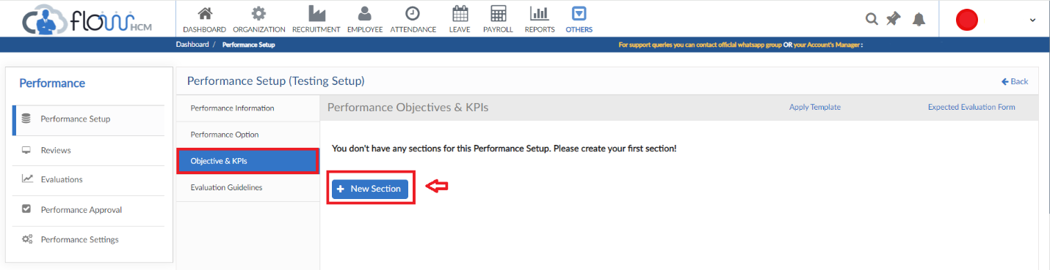
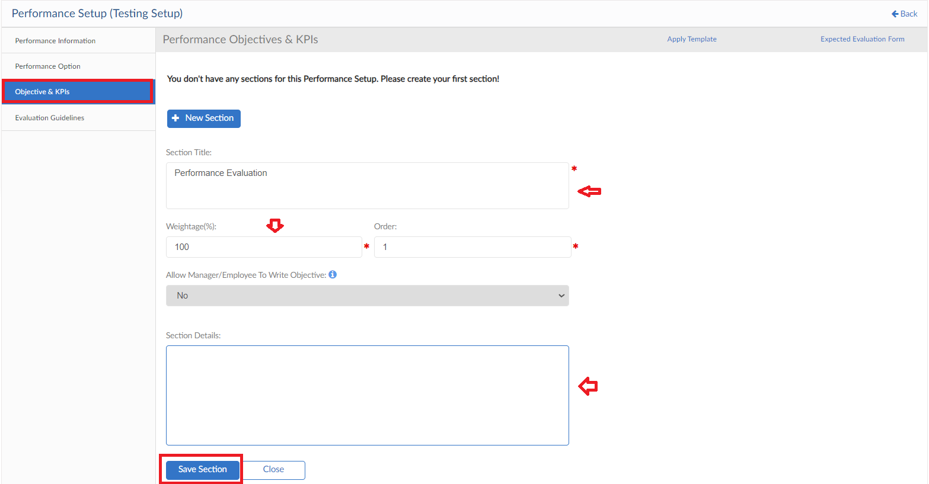

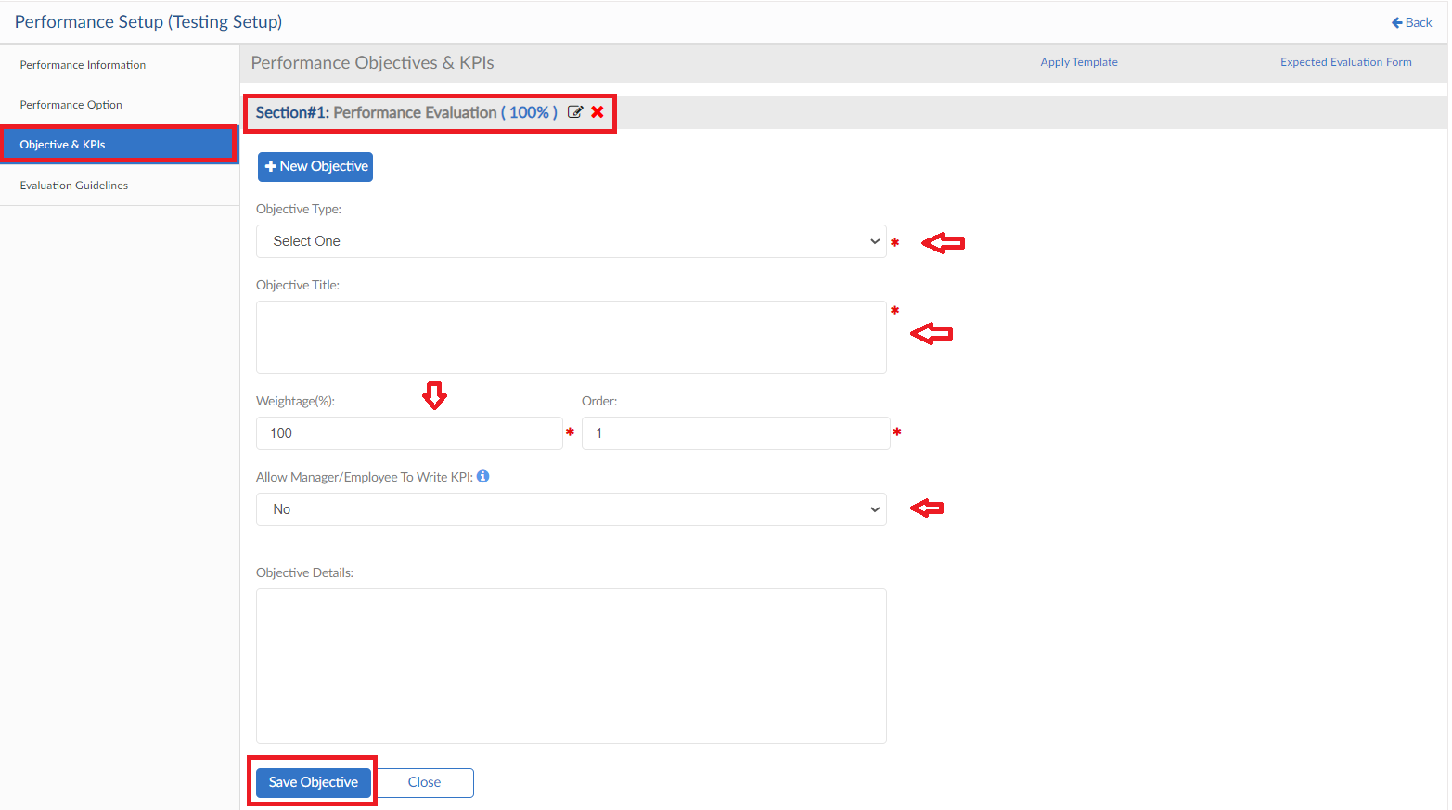
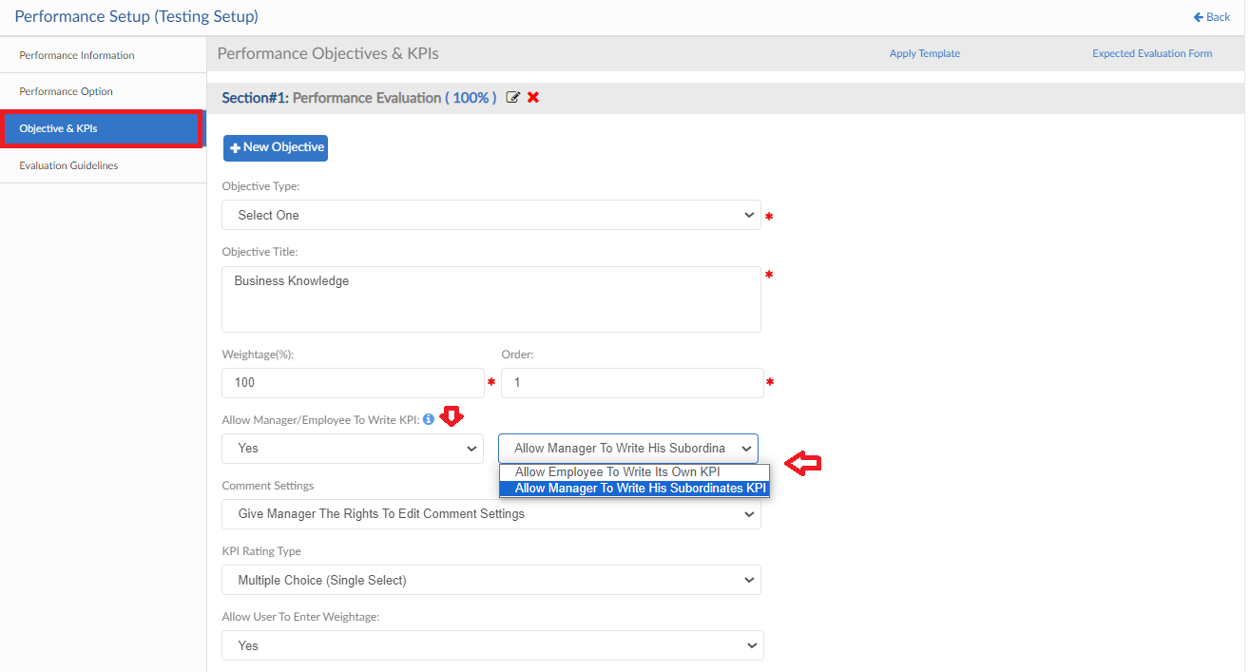
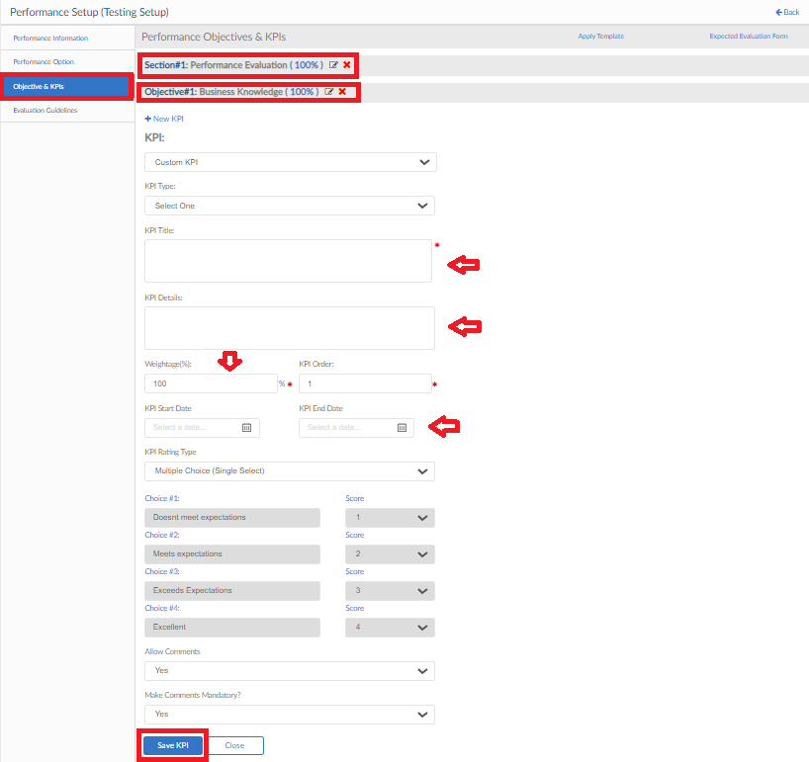
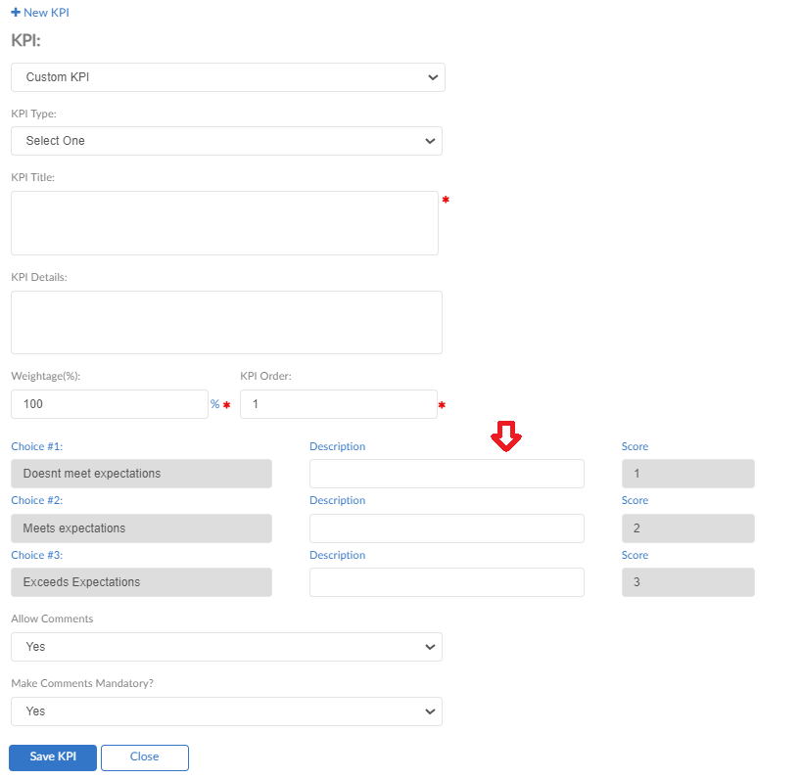
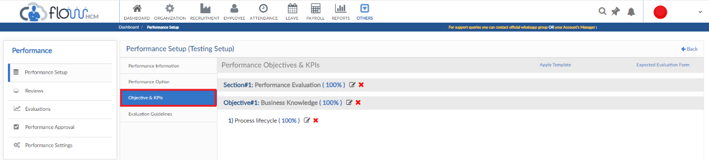

Evaluation Guidelines
- Next step you can add Guidelines/Instruction if required in Evaluation Form
- Add a title and select the review type to whom the guidelines will be visible
- Enter description and click on update button

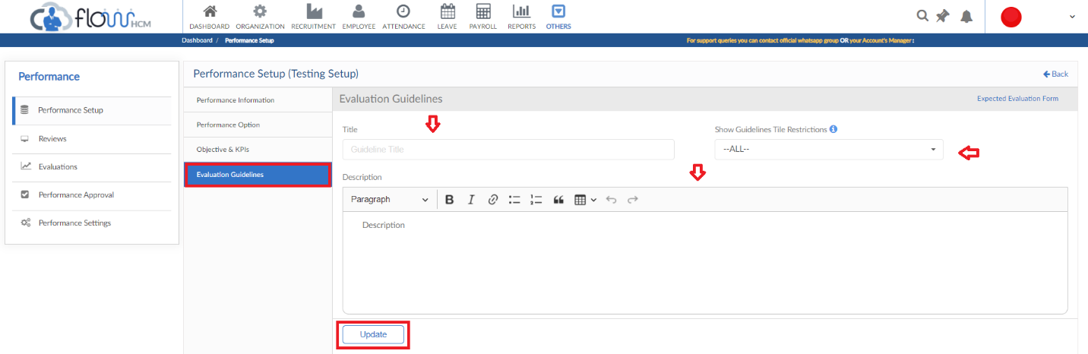
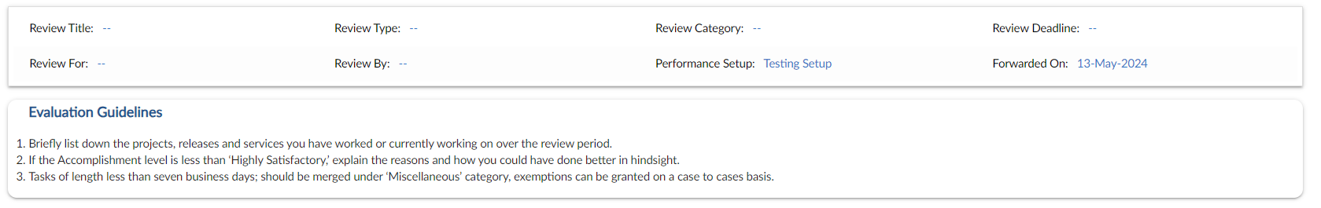

Performance Review

- Move to next tab that is review and click on New Review button
- To add review, enter the information of Employee selection, Title, Performance Setup and Review Category
- Self, Line Manager, Additional (Peers) and Final Review types are allowed to be mapped in a performance cycle of selected employees
- Incase of Matrix Box Modifier Review type field will be enabled
- Performance Setup if Section wise, a field will be visible “Allow to Score Section” against all Review types
- Set parameters for all review types and click on Send Review button or Save as Draft

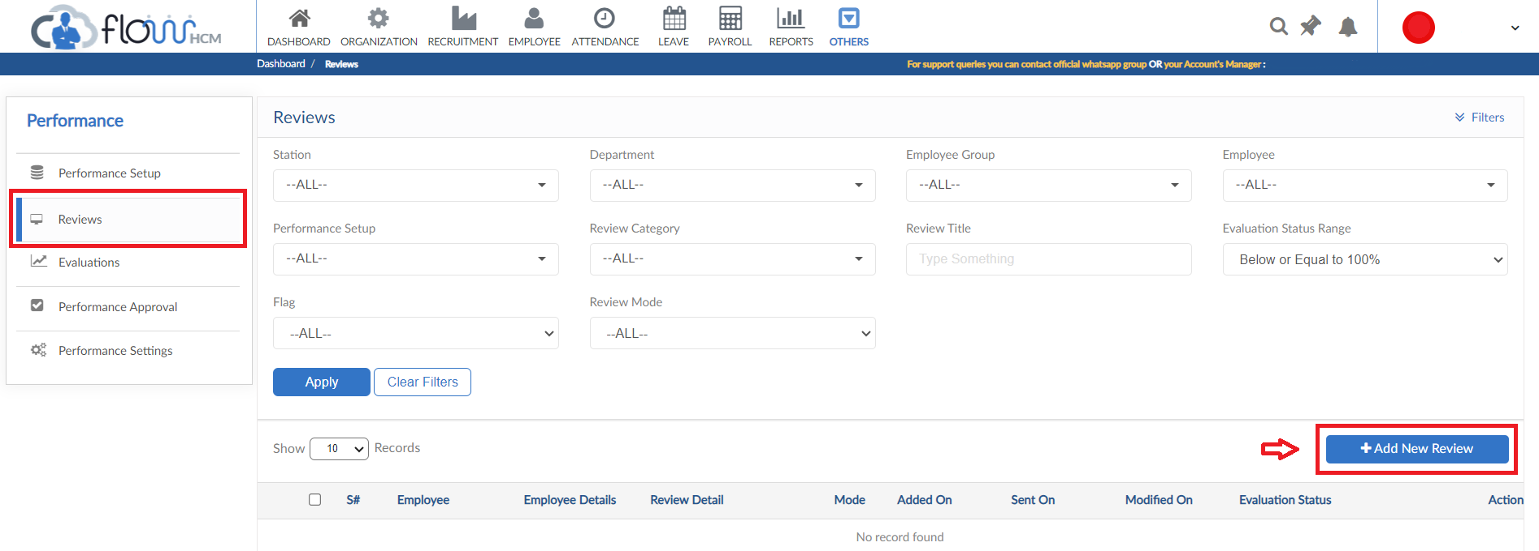
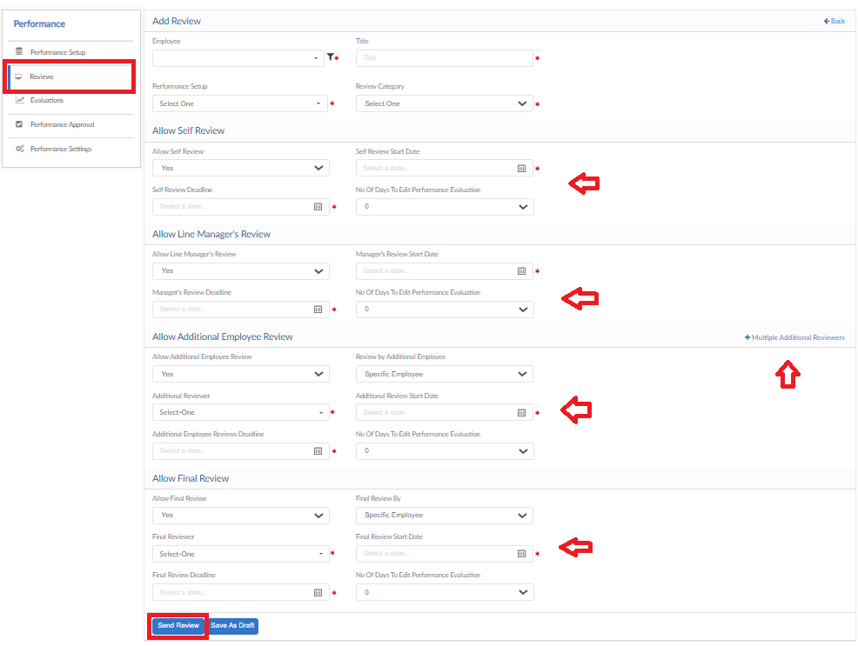
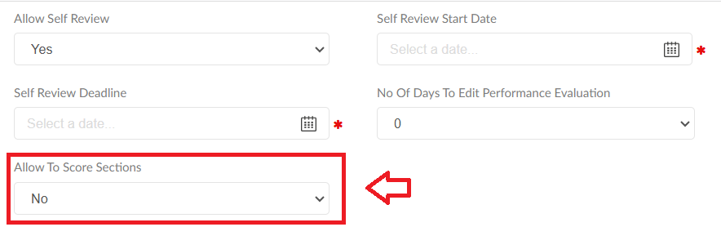

Performance Evaluation

- Evaluation Tab will show the pending/completed evaluation of Employee
- Grid will show all the details of Employee Review
- Click on Evaluate in Action dropdown
- Evaluation from will be visible as per parameters set
- User can score and add comments through this form
- Additional employee feedback tiles are also available to fill
- In the end weightage and final score will be shown as per user scoring
- Click on Submit Performance Evaluation button

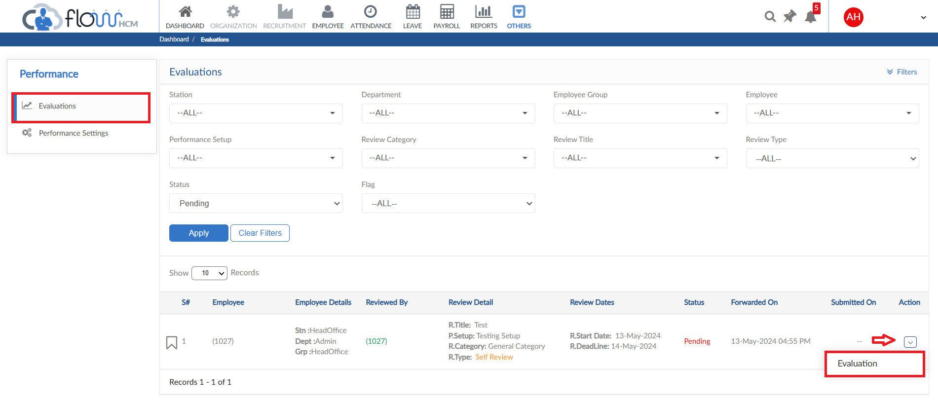

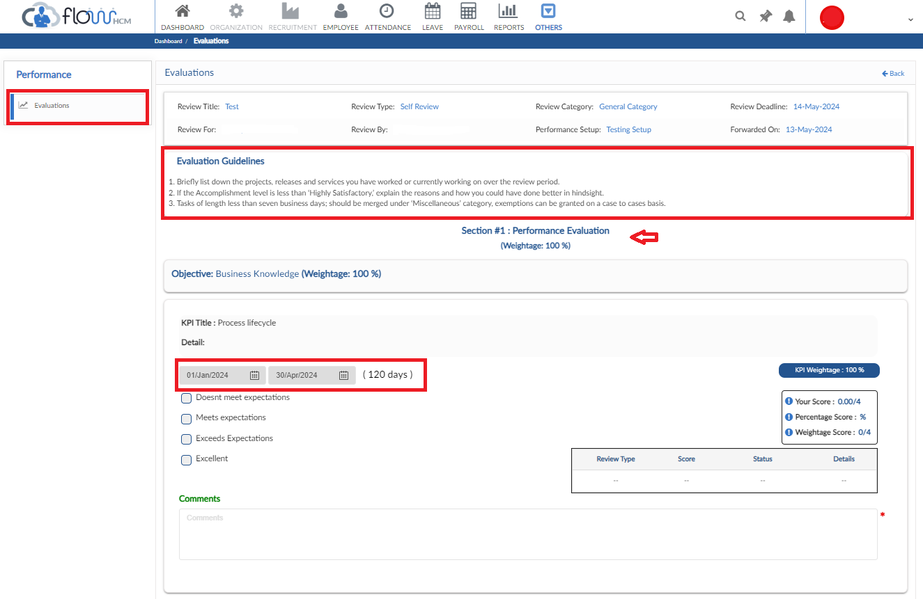
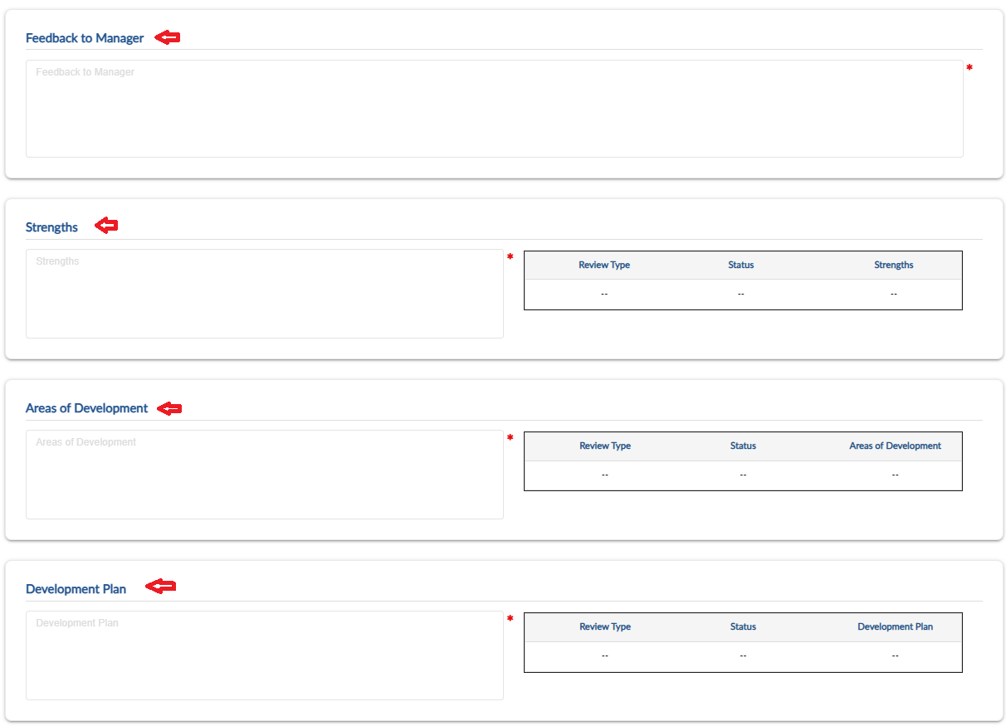
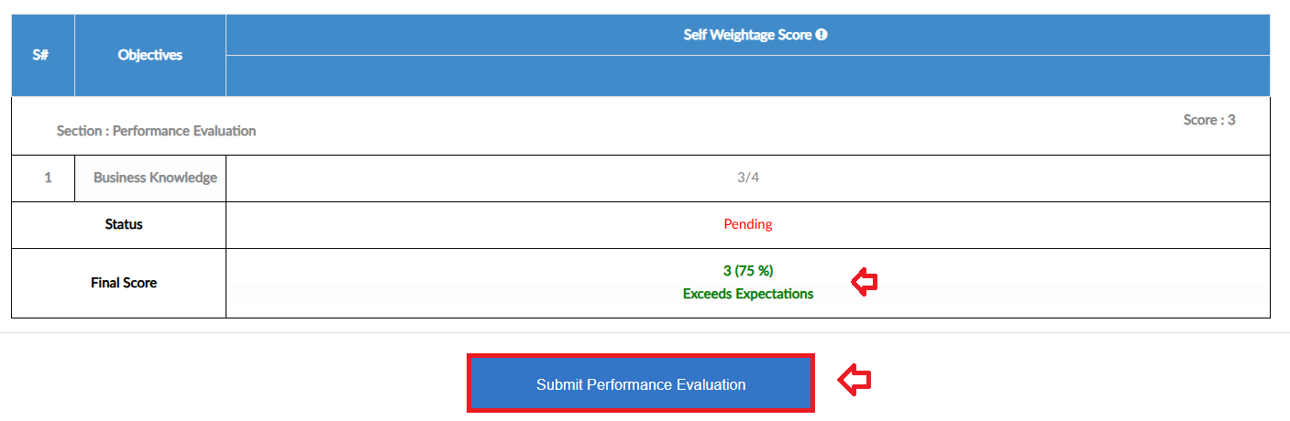

Performance Approval

- In case of routing process, creation of Objective/KPI at any employee end will be approved through this TAB
- The entered Objective/KPI by employee will be shown in grid in detail
- The approver can either Approve/Reject the request along with adding remarks

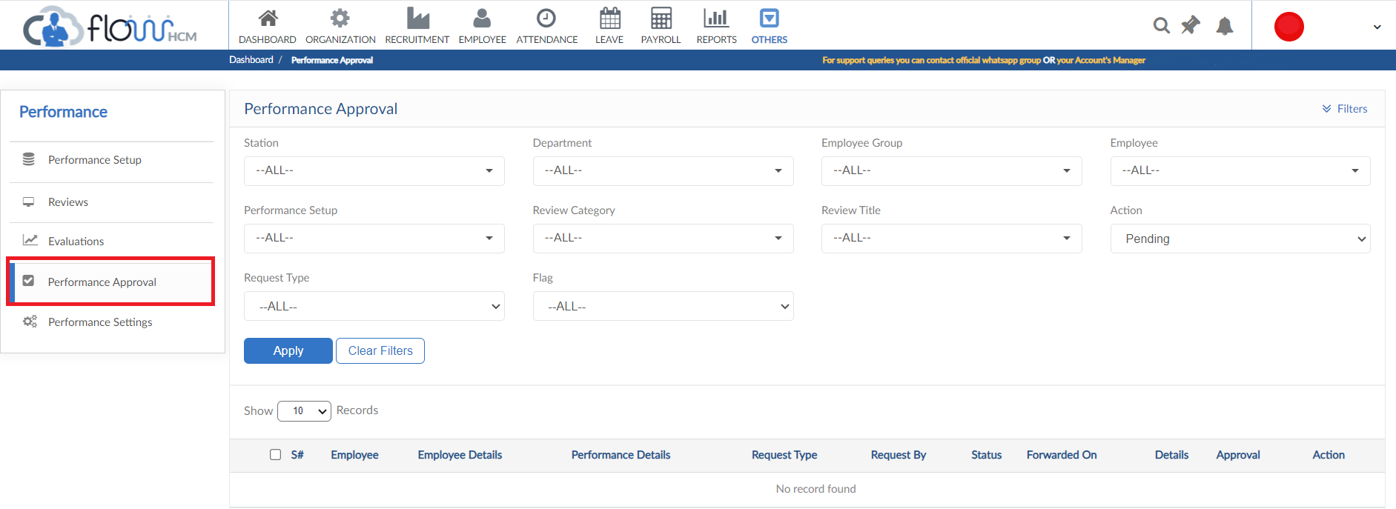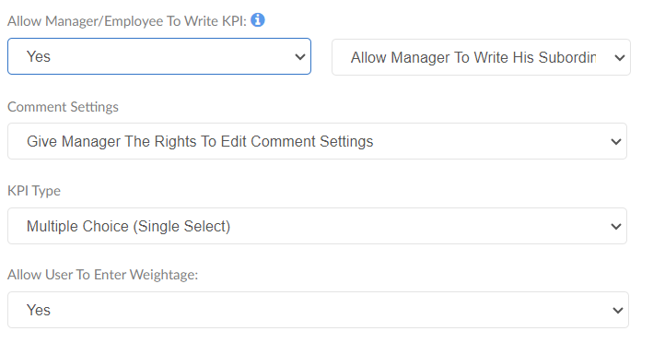

Performance Settings

- Performance Settings consists of multiple forms for setup and evaluation

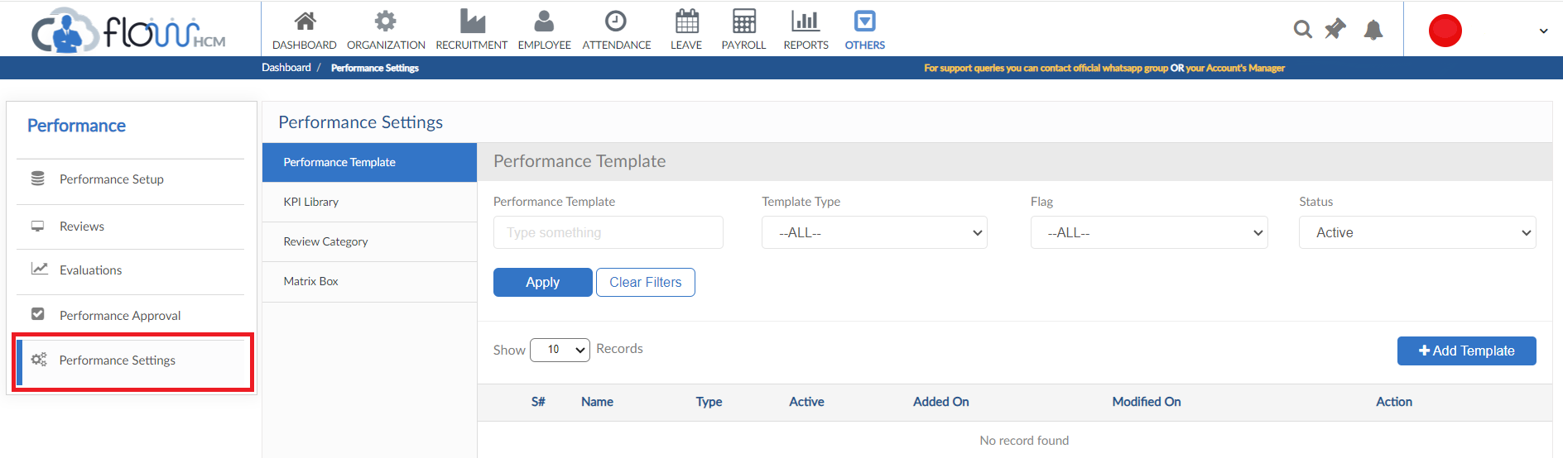

Performance Template
- Click on Add Template button to create a performance template
- Select the criteria for template and construct a performance template
- The template can be used in Objective and KPI form
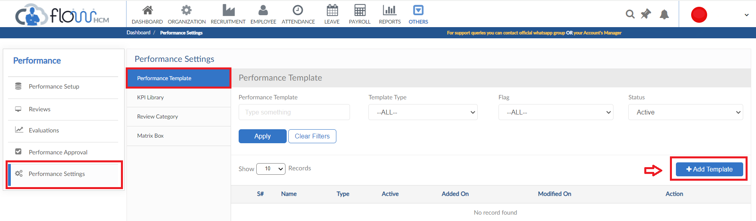
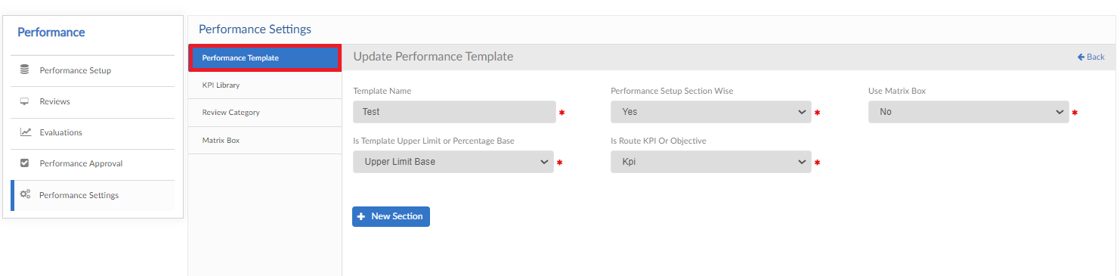

KPI Library
- Click on Add KPI Library to create a KPI
- Add the KPI and description then click ADD
- The form will create a listing of KPI called Library, used in Objective/KPI creation

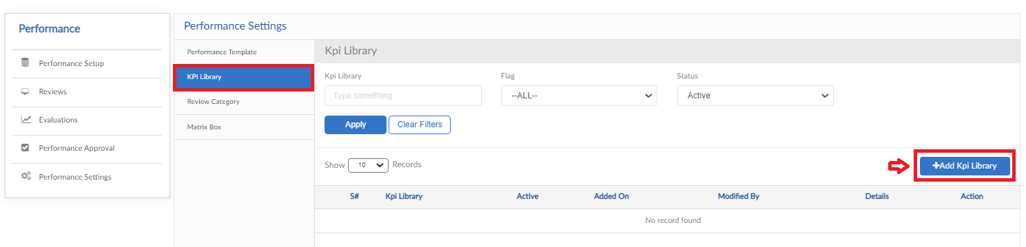
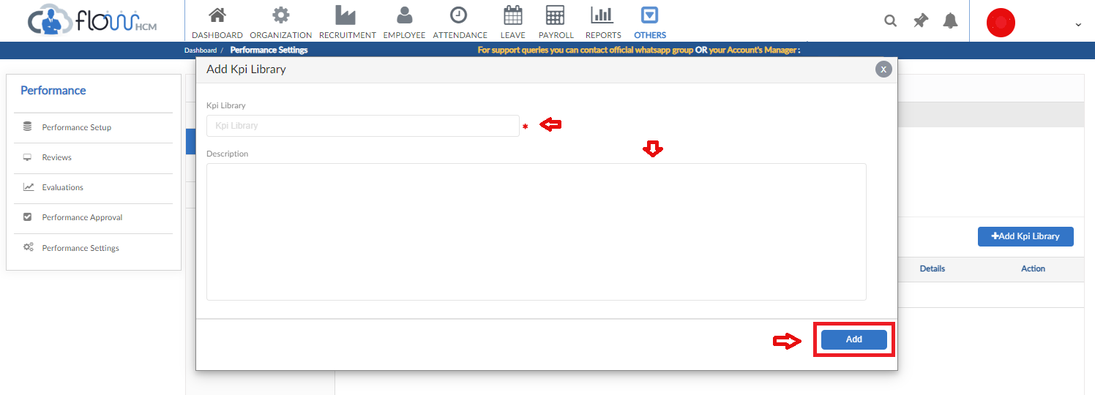

Review Category
- Click on Add Review category to create categories
- Add the category title and description then click Add
- The form will create Review Category listing, used while generating Employee review

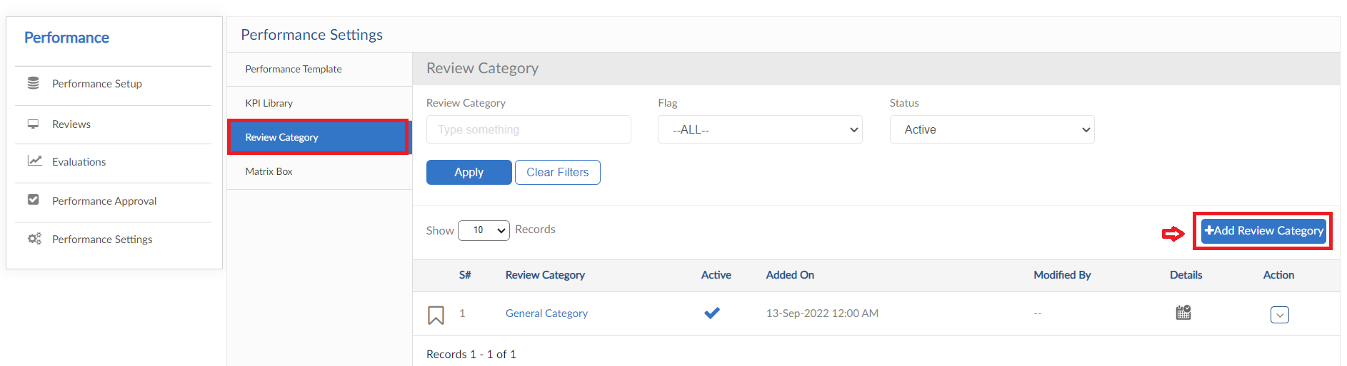
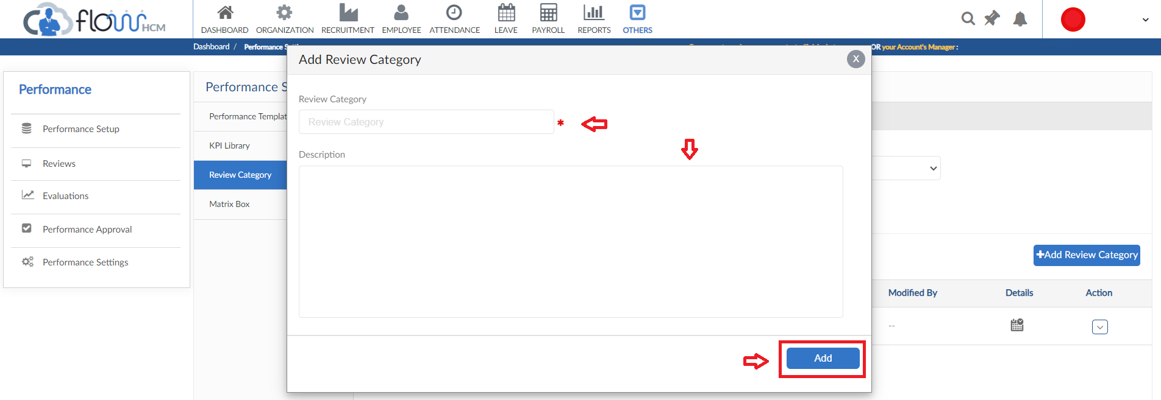

Matrix Box
- This form consists of the setting of Matrix box
- Choose the Matrix process (9 or 12) fill the boxes with required information
- Can even set colors of every box differently and click save
- Choices for evaluation can be specified through performance option Tab

